**Android App Testing Screenshots**

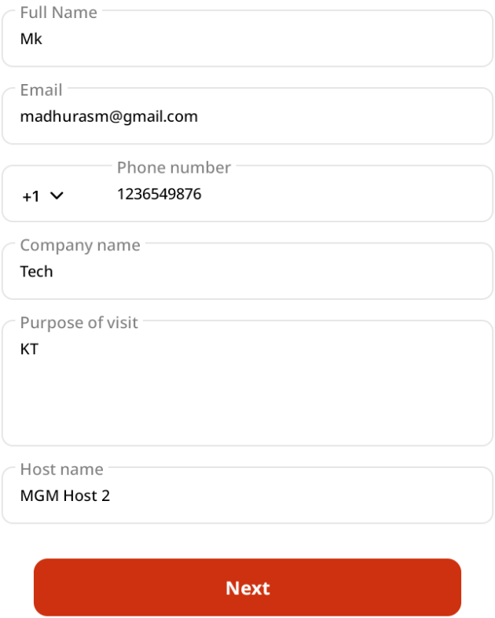

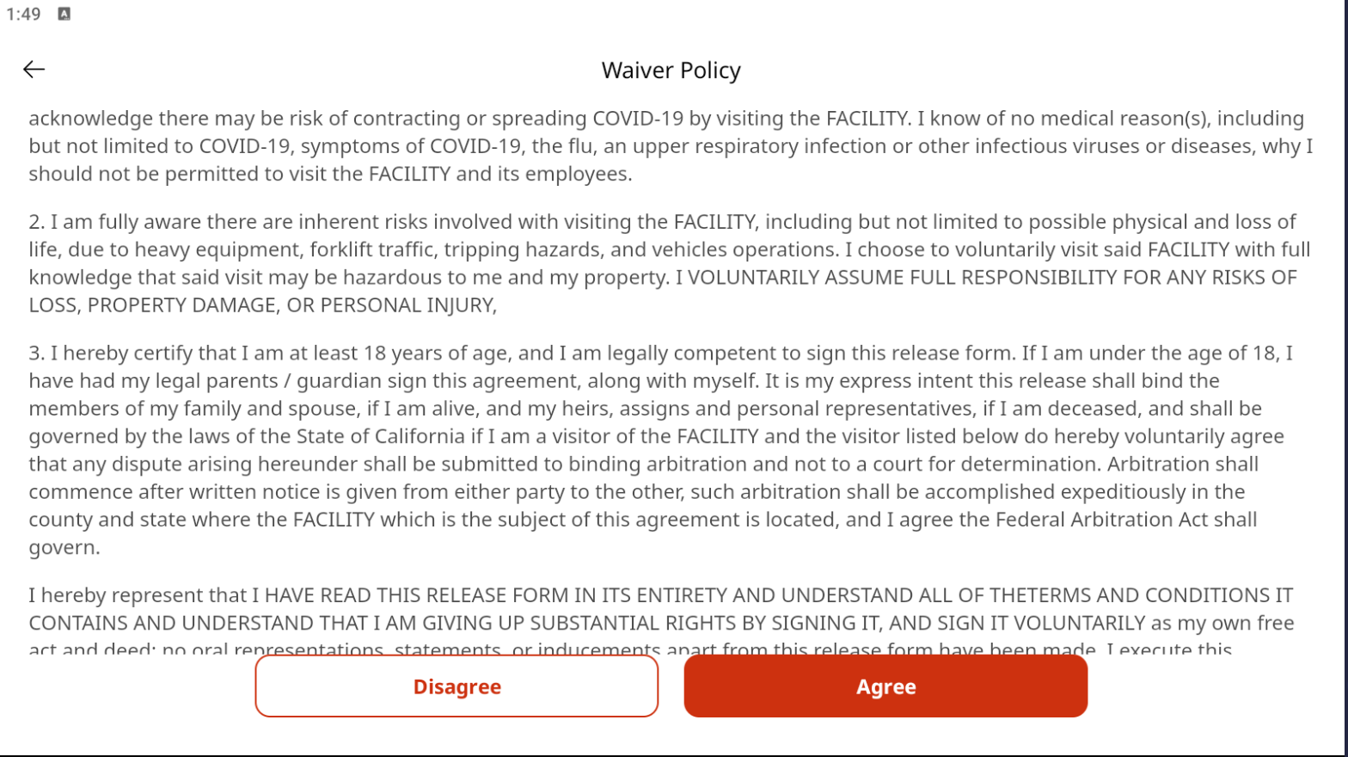

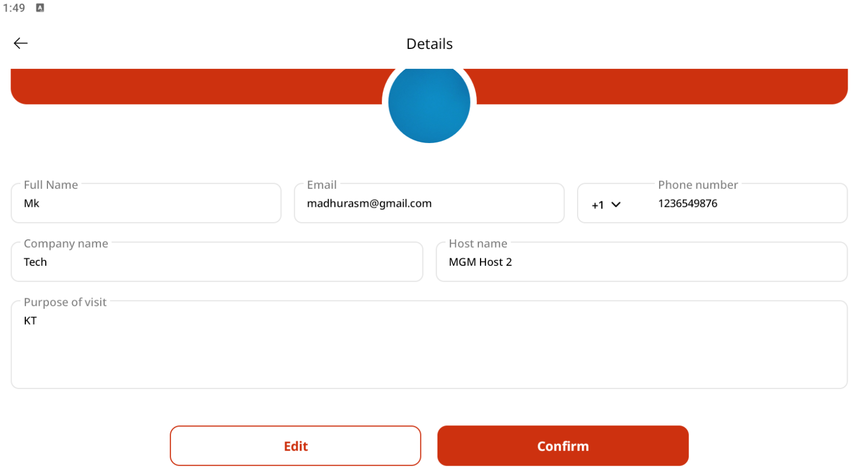

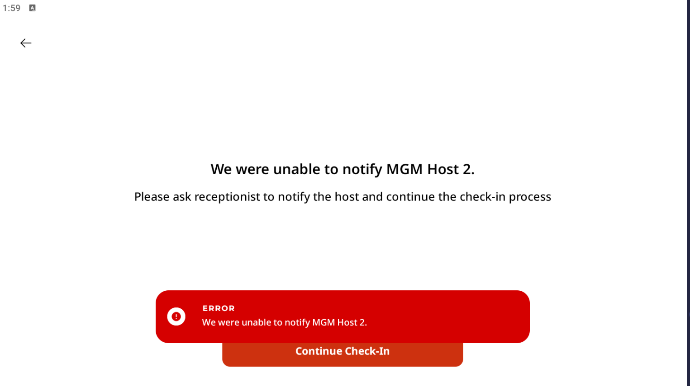

After logging in with appropriate credentials in <http://20.62.193.142/panel/visitor-check-ins/391>, visitor list was displayed in the dashboard. But, there is no option for the receptionist to notify the host. Hence, for all visitors, the dashboard status is

* When Check-Out button is not clicked

**Check-Out Time** Not Available

**Visitor Request Status** Pending

* When Check-Out button is clicked

**Check-Out Time** Jul 21, 2025 05:51 PM (Eg.)

**Visitor Request Status** Pending

**Login sheet**

Row No.: 2

|  |  |  |  |  |
| --- | --- | --- | --- | --- |
| **Description** | **Test Steps** | **Expected Output** | **Status** | **Comments** |
| Verify successful login with valid credentials | 1. Navigate to the receptionist login page 2. Enter a valid email in the username field 3. Enter a valid password in the password field 4. Click on the Submit button | 1. User should be successfully logged in 2. User should be redirected to the dashboard or home page 3. A welcome message should be displayed | **Pass** | Successful login with valid credentials |

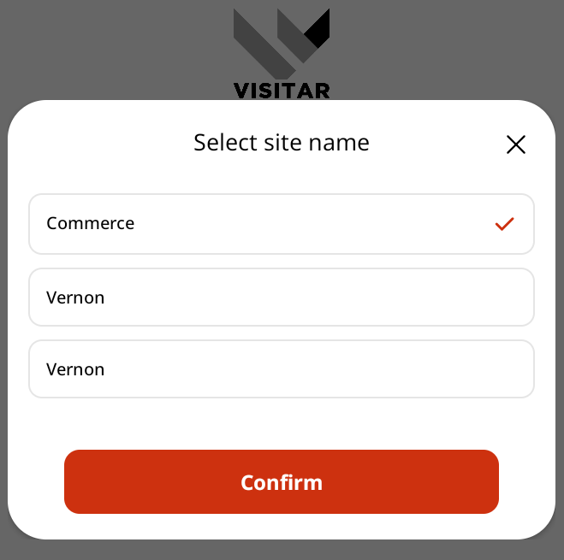



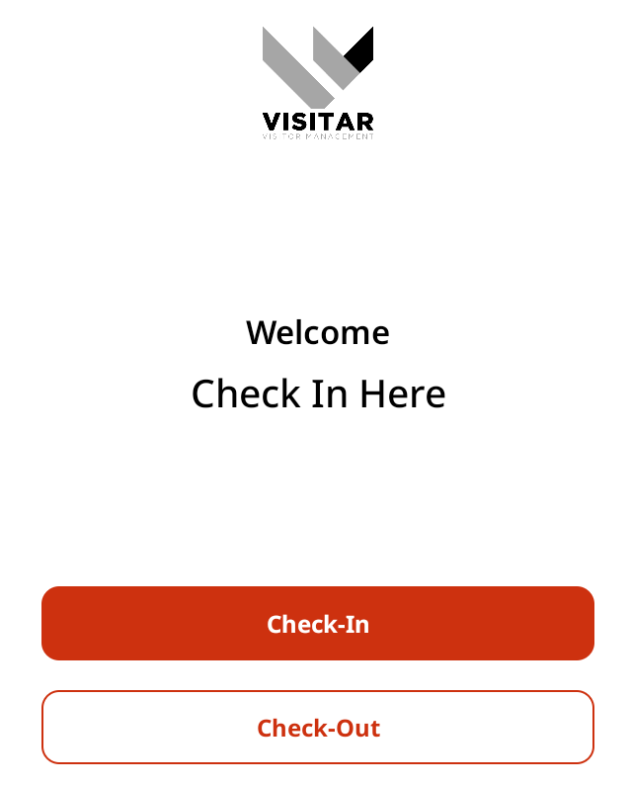

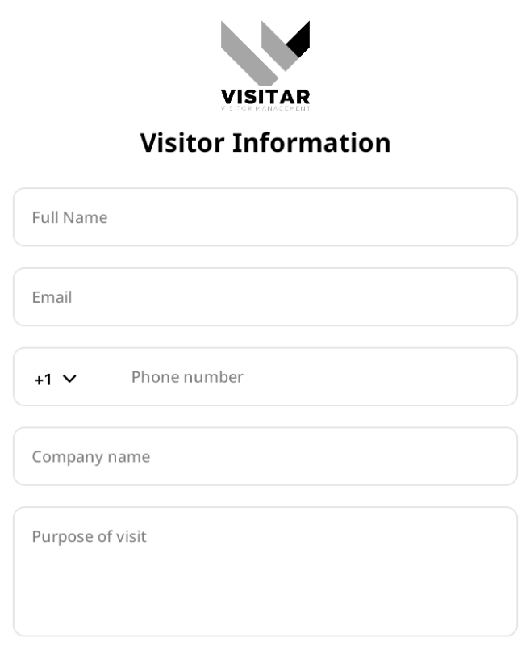

Row No.: 3

|  |  |  |  |  |
| --- | --- | --- | --- | --- |
| **Description** | **Test Steps** | **Expected Output** | **Status** | **Comments** |
| Verify login with valid email and invalid password | 1. Navigate to the receptionist login page 2. Enter a valid email in the username field 3. Enter an invalid password in the password field 4. Click on the Submit button | 1. User should not be logged in 2. A validation error message should appear on the page 3. The message should indicate that the password is incorrect | **Pass** | For invalid password, it displays the error message regarding a valid password format |

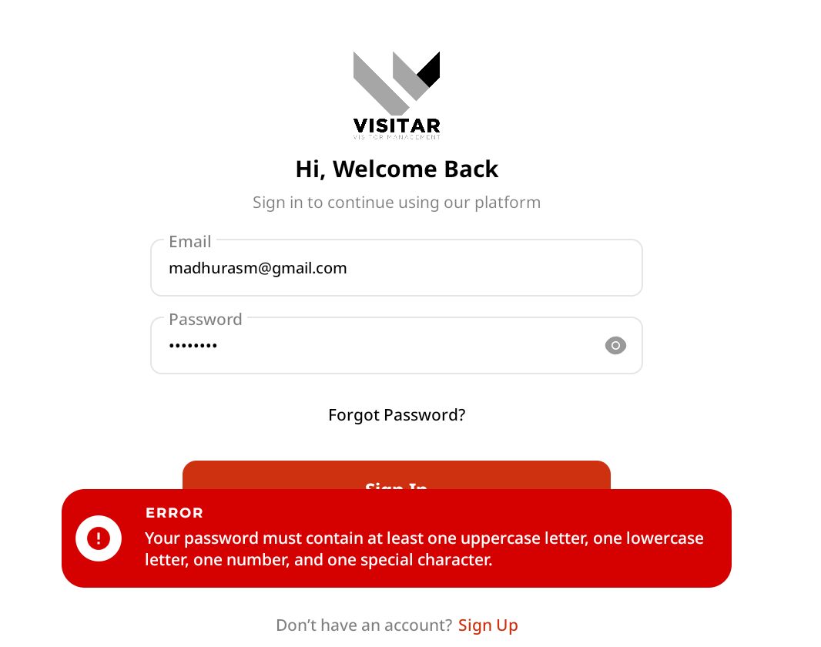

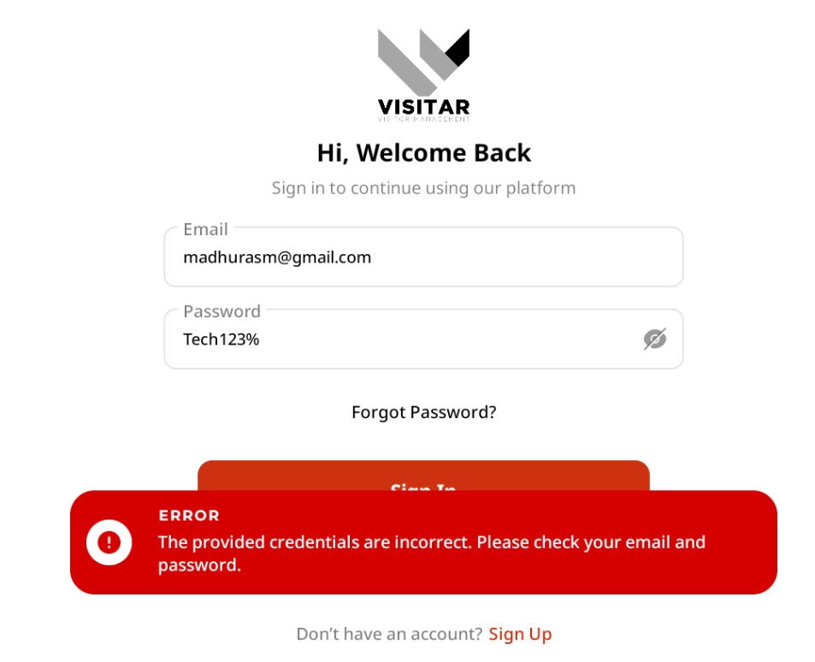

Row No.: 4

|  |  |  |  |  |
| --- | --- | --- | --- | --- |
| **Description** | **Test Steps** | **Expected Output** | **Status** | **Comments** |
| Verify login with invalid email and valid password | 1. Navigate to the receptionist login page 2. Enter an invalid email in the username field 3. Enter a valid password in the password field 4. Click on the Submit button | 1. User should not be logged in 2. A validation error message should appear on the page 3. The message should indicate that the email is incorrect | **Pass** | For invalid email, it displays the message that the email does not exist. |

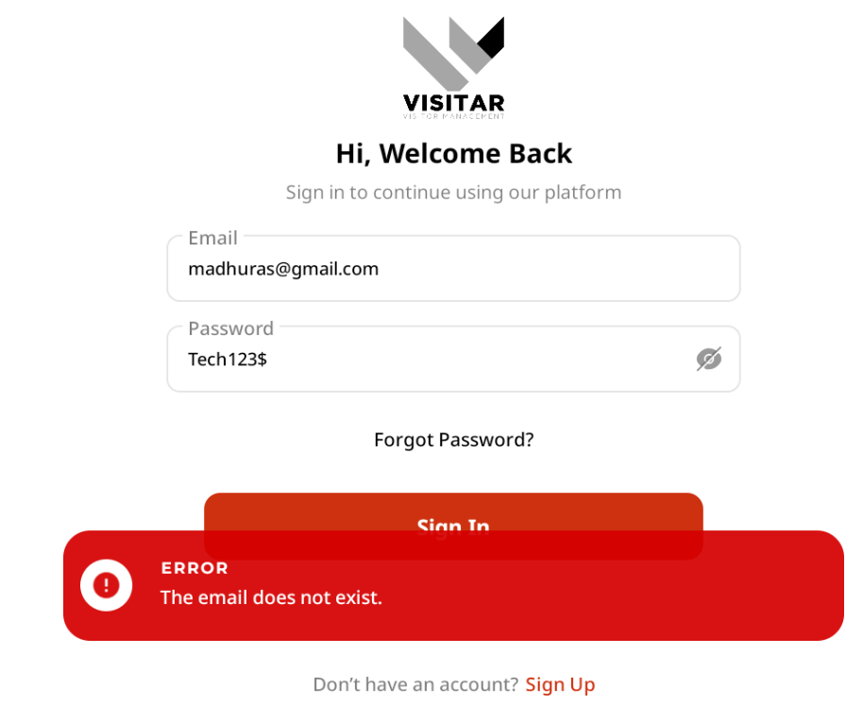

Row No.: 5

|  |  |  |  |  |
| --- | --- | --- | --- | --- |
| **Description** | **Test Steps** | **Expected Output** | **Status** | **Comments** |
| Verify login with invalid email and invalid password | 1. Navigate to the receptionist login page 2. Enter an invalid email in the username field 3. Enter an invalid password in the password field 4. Click on the Submit button | 1. User should not be logged in 2. A validation error message should appear on the page 3. The message should indicate that the credentials are incorrect | **Pass** | Displays the error message as “The email does not exist” |

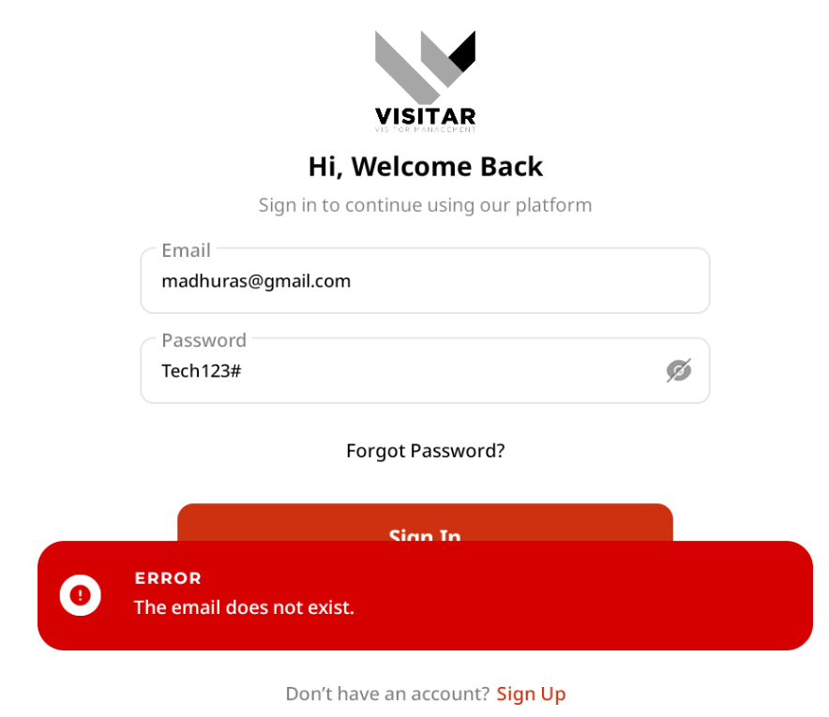

Row No.: 6

|  |  |  |  |  |
| --- | --- | --- | --- | --- |
| **Description** | **Test Steps** | **Expected Output** | **Status** | **Comments** |
| Verify login with empty email and valid password | 1. Navigate to the receptionist login page 2. Leave the email field empty 3. Enter a valid password in the password field 4. Click on the Submit button | 1. User should not be logged in 2. A validation error message should appear on the page 3. The message should indicate that the email field is required | **Pass** | User is not logged and displays the error message “Please enter email address” |

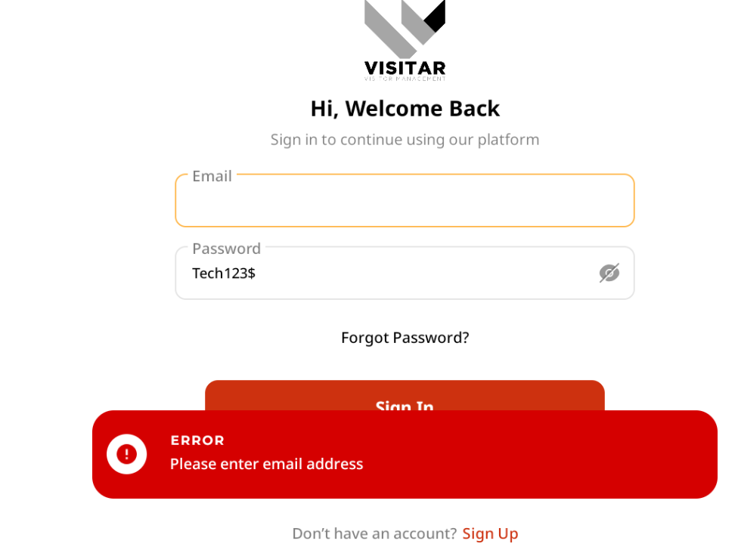

Row No.: 7

|  |  |  |  |  |
| --- | --- | --- | --- | --- |
| **Description** | **Test Steps** | **Expected Output** | **Status** | **Comments** |
| Verify login with valid email and empty password | 1. Navigate to the receptionist login page 2. Enter a valid email in the username field 3. Leave the password field empty 4. Click on the Submit button | 1. User should not be logged in 2. A validation error message should appear on the page 3. The message should indicate that the password field is required | **Pass** | Displays the message to enter the password |

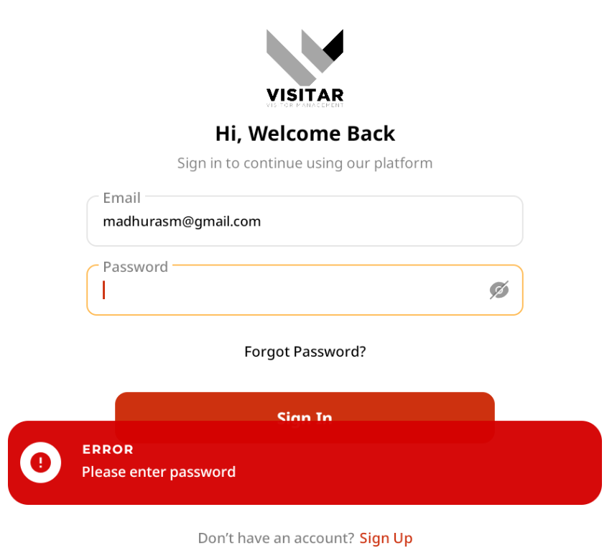

Row No.: 8

|  |  |  |  |  |
| --- | --- | --- | --- | --- |
| **Description** | **Test Steps** | **Expected Output** | **Status** | **Comments** |
| Verify login with empty email and empty password | 1. Navigate to the receptionist login page 2. Leave the email field empty 3. Leave the password field empty 4. Click on the Submit button | 1. User should not be logged in 2. A validation error message should appear on the page 3. The message should indicate that both fields are required | **Pass** | Displays only the error message “Please enter email address” |

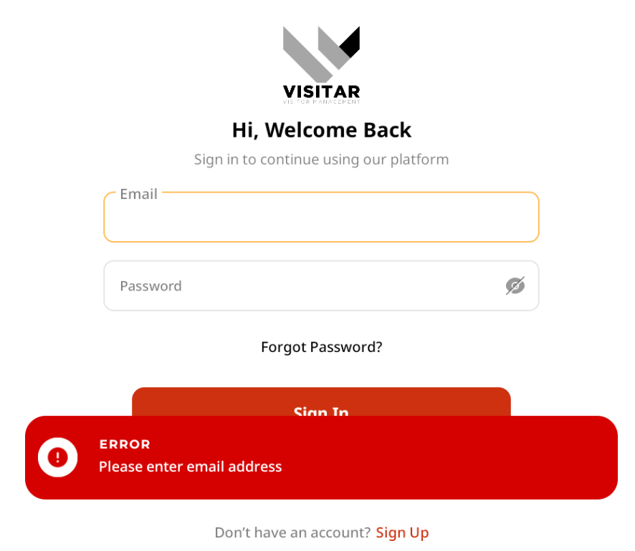

Row No.: 9

|  |  |  |  |  |
| --- | --- | --- | --- | --- |
| **Description** | **Test Steps** | **Expected Output** | **Status** | **Comments** |
| Verify login with special characters in email field | 1. Navigate to the receptionist login page 2. Enter special characters (e.g., @#$%) in the email field 3. Enter a valid password in the password field 4. Click on the Submit button | 1. User should not be logged in 2. A validation error message should appear on the page 3. The message should indicate that the email format is invalid | **Pass** | Displays the error message indicating that the email format is invalid. |

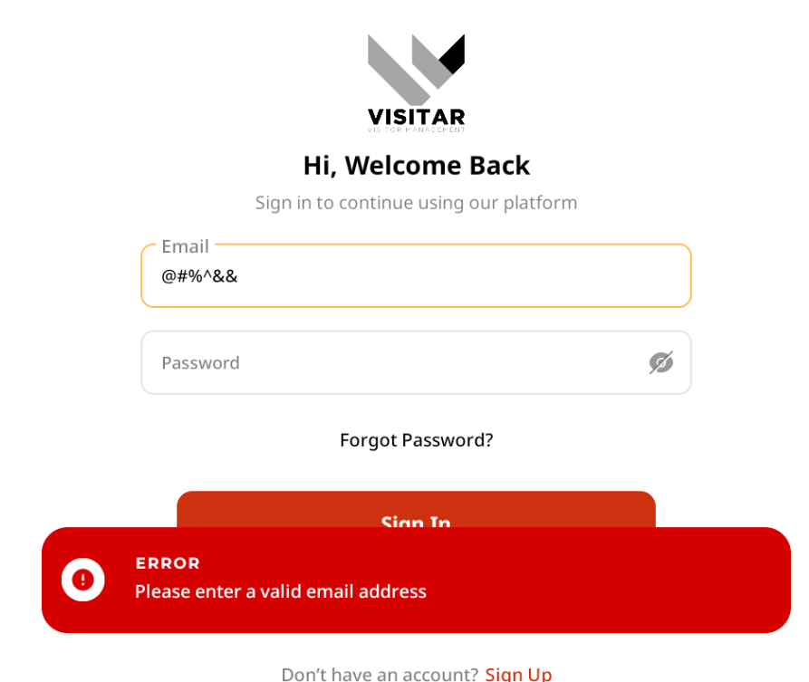

Row No.: 10

|  |  |  |  |  |
| --- | --- | --- | --- | --- |
| **Description** | **Test Steps** | **Expected Output** | **Status** | **Comments** |
| Verify login with very long email input | 1. Navigate to the receptionist login page 2. Enter an extremely long string in the email field (e.g., 1000 characters) 3. Enter a valid password in the password field 4. Click on the Submit button | 1. A validation message should be appearing on the page. | **Pass** | For a very long email input, it displays the error message “Please enter a valid email address” |

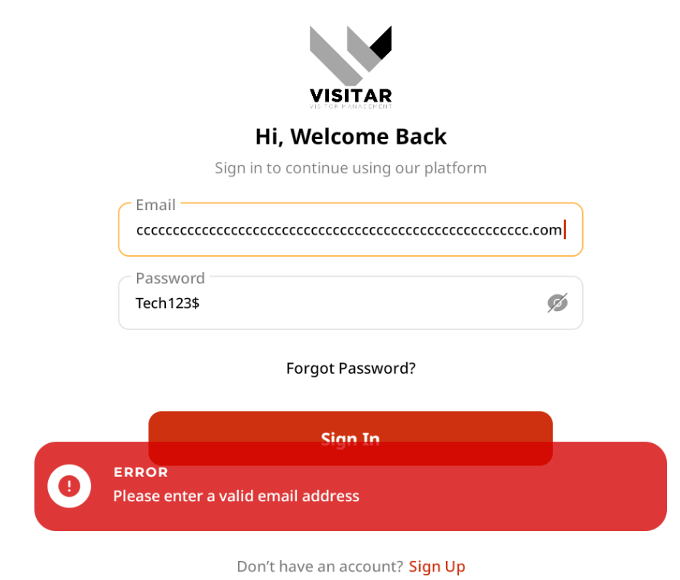

Row No.: 11

|  |  |  |  |  |
| --- | --- | --- | --- | --- |
| **Description** | **Test Steps** | **Expected Output** | **Status** | **Comments** |
| Verify login with very long password input | 1. Navigate to the receptionist login page 2. Enter a valid email in the username field 3. Enter an extremely long string in the password field (e.g., 1000 characters) 4. Click on the Submit button | 1. A validation message should be appearing on the page. | **Pass** | For a very long password, displays a validation message giving the valid password format |

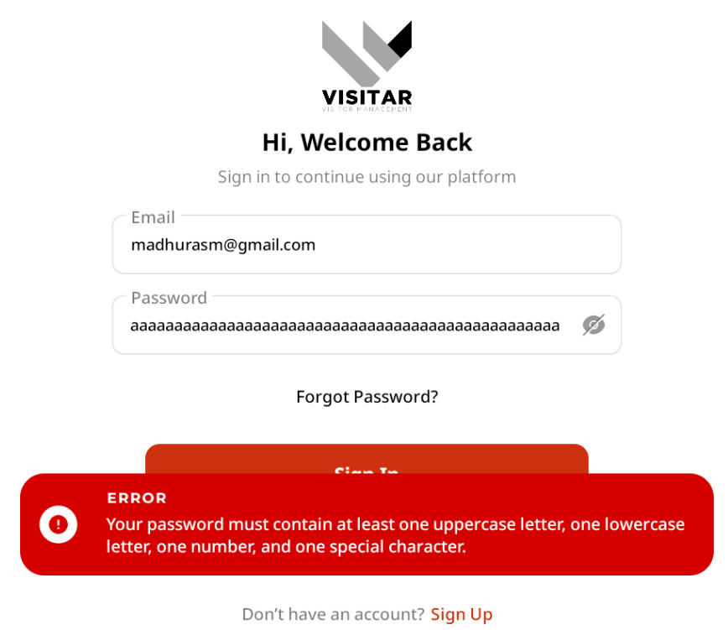

Row No.: 12

|  |  |  |  |  |
| --- | --- | --- | --- | --- |
| **Description** | **Test Steps** | **Expected Output** | **Status** | **Comments** |
| Verify password masking functionality | 1. Navigate to the receptionist login page 2. Enter a password in the password field 3. Observe the password field | 1. The password should be masked (displayed as dots or asterisks) 2. The actual characters should not be visible | **Pass** | Password is masked and displayed as dots, making the actual characters to not be visible |

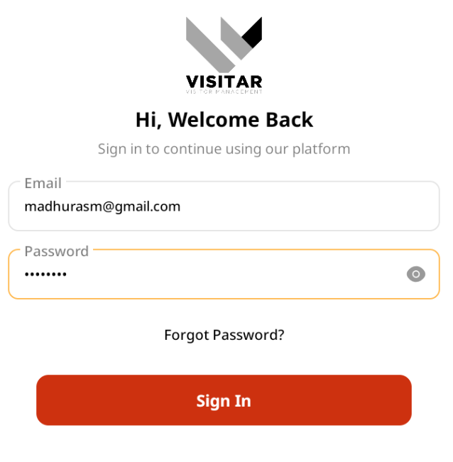

Row No.: 13

|  |  |  |  |  |
| --- | --- | --- | --- | --- |
| **Description** | **Test Steps** | **Expected Output** | **Status** | **Comments** |
| Verify 'Show Password' functionality | 1. Navigate to the receptionist login page 2. Enter a password in the password field 3. Click on the 'Show Password' icon or checkbox (if available) | 1. When clicked, the password should become visible 2. When clicked again, the password should be masked again | **Pass** | Clicking on the ‘Show Password’ causes the password to become visible or be masked again. |

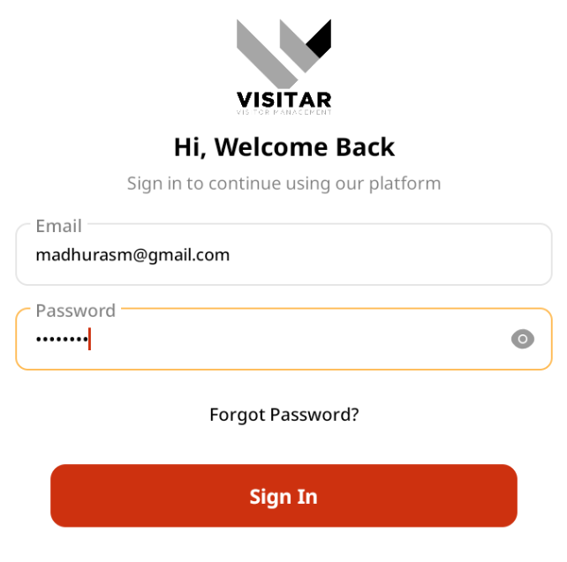

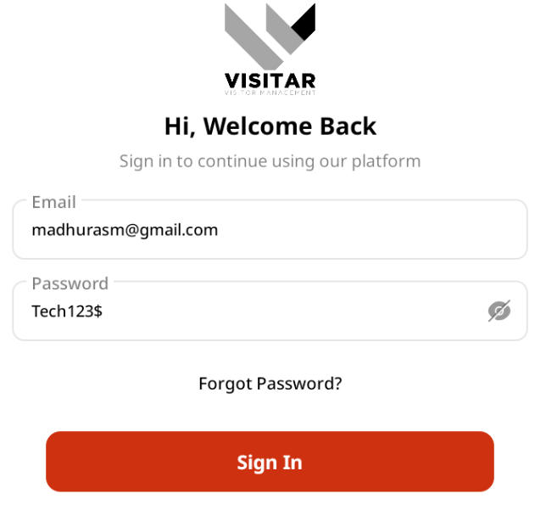

Row No.: 14

|  |  |  |  |  |
| --- | --- | --- | --- | --- |
| **Description** | **Test Steps** | **Expected Output** | **Status** | **Comments** |
| Verify accessibility of login form with keyboard navigation | 1. Navigate to the receptionist login page 2. Use Tab key to navigate through the form elements 3. Use Enter key to submit the form with valid credentials | 1. User should be able to navigate through all form elements using the Tab key 2. User should be able to submit the form using the Enter key 3. Login should be successful with valid credentials | **Pass** | Using the Tab key for navigation through the form elements and Enter key to submit the form was successful |

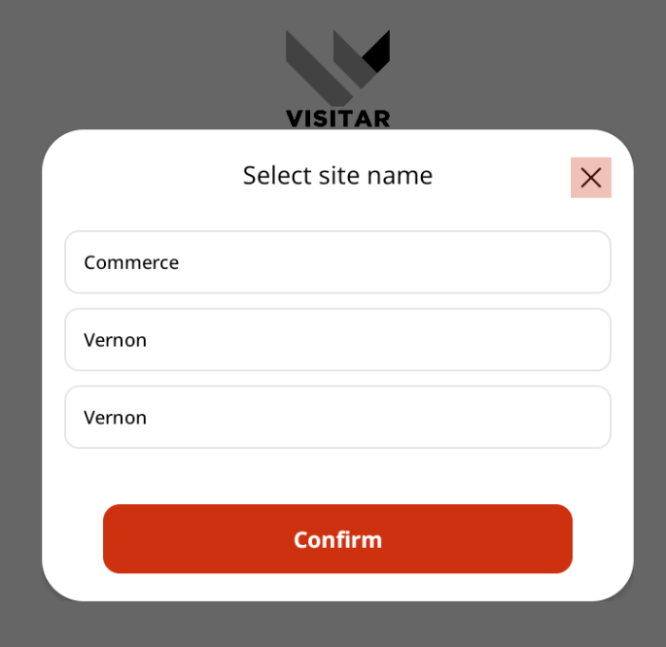

Row No.: 15

|  |  |  |  |  |
| --- | --- | --- | --- | --- |
| **Description** | **Test Steps** | **Expected Output** | **Status** | **Comments** |
| Verify login page UI elements | 1. Navigate to the receptionist login page 2. Observe all UI elements | 1. All required elements should be present: email field, password field, submit button 2. Optional elements may include: 'Remember Me' checkbox, 'Forgot Password' link 3. All elements should be properly aligned and formatted | **Pass** | All elements are properly aligned and formatted |

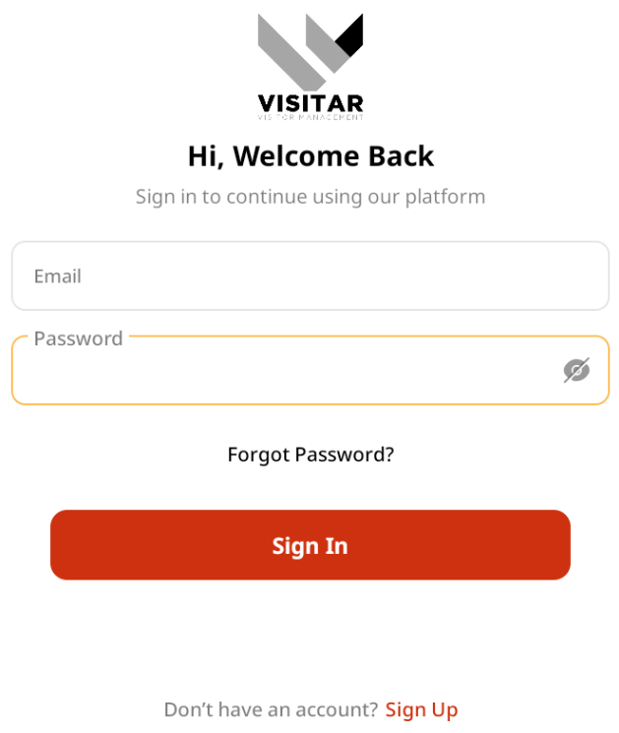

Row No.: 16

|  |  |  |  |  |
| --- | --- | --- | --- | --- |
| **Description** | **Test Steps** | **Expected Output** | **Status** | **Comments** |
| Verify login with case-sensitive email | 1. Navigate to the receptionist login page 2. Enter a valid username with different case (e.g., if username is 'Receptionist1', enter 'receptionist1') 3. Enter a valid password 4. Submit the form | 1. If the system is designed to be case-insensitive for usernames/emails, login should be successful 2. If case-sensitive, the appropriate error message should be displayed | **Pass** | Case-insensitivity for username/emails was successful |

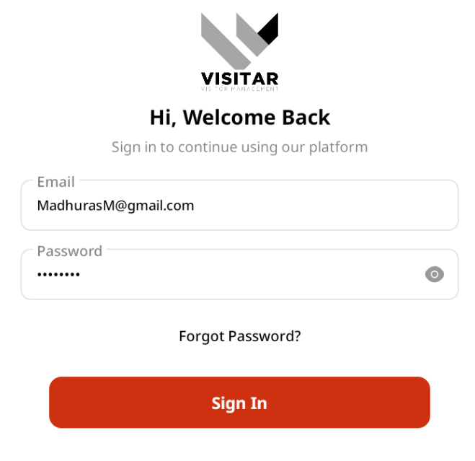

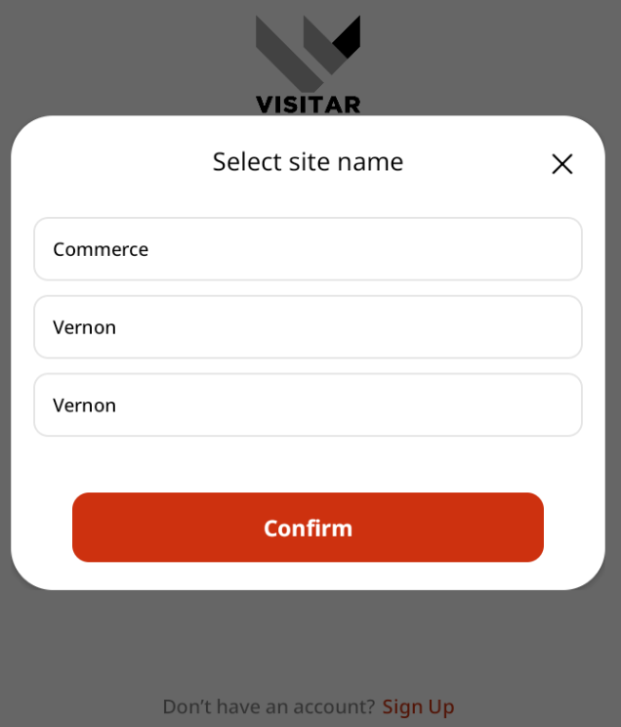

Row No.: 17

|  |  |  |  |  |
| --- | --- | --- | --- | --- |
| **Description** | **Test Steps** | **Expected Output** | **Status** | **Comments** |
| Verify login with case-sensitive password | 1. Navigate to the receptionist login page 2. Enter a valid email 3. Enter a valid password with incorrect case (e.g., if password is 'Password123', enter 'password123') 4. Submit the form | 1. The login should fail as passwords are typically case-sensitive 2. An appropriate error message should be displayed | **Pass** | Case-sensitivity for passwords displayed the error message |

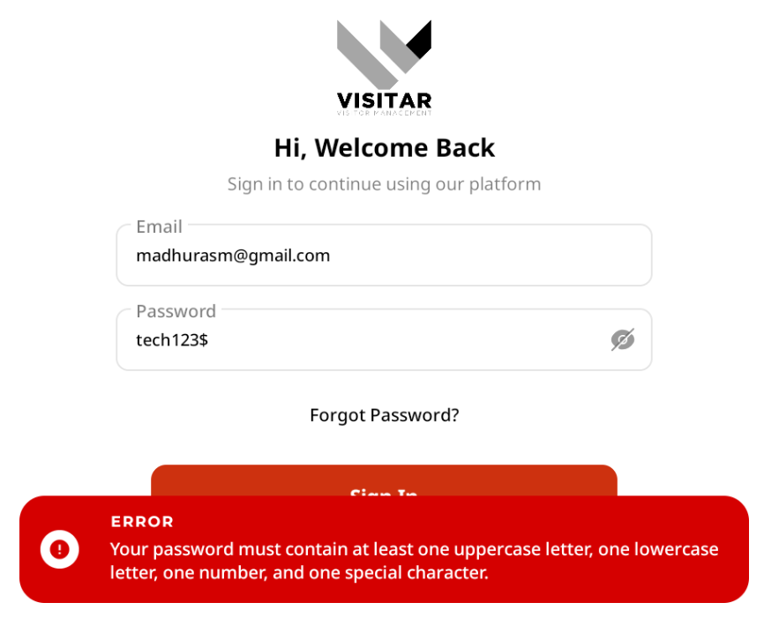

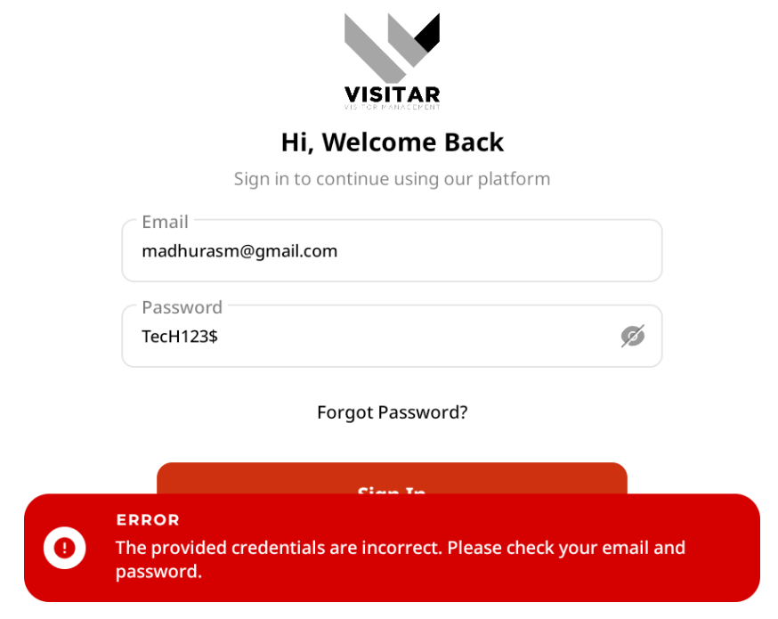

Row No.: 18

|  |  |  |  |  |
| --- | --- | --- | --- | --- |
| **Description** | **Test Steps** | **Expected Output** | **Status** | **Comments** |
| Verify login after back button usage | 1. Login successfully 2. Navigate to another page 3. Click the browser's back button 4. Attempt to use the application | 1. User should remain logged in 2. User should not be able to see the login page again unless explicitly logged out | **Pass** | User remains logged in when the browser’s back button is clicked until logged out |

**This is in the browser**

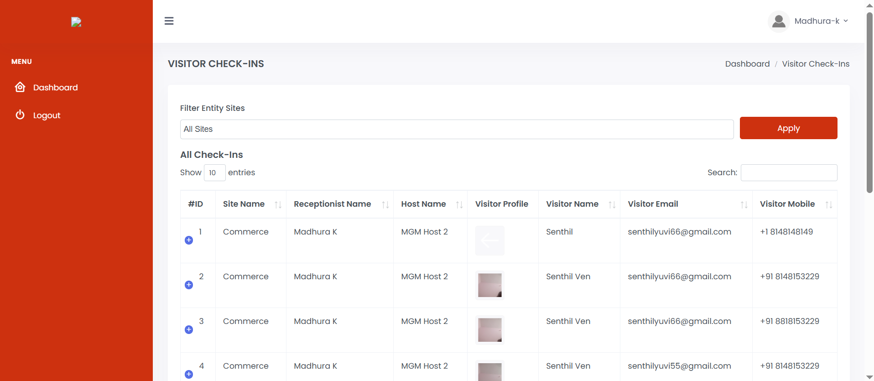

After Clicking the browser’s back button,

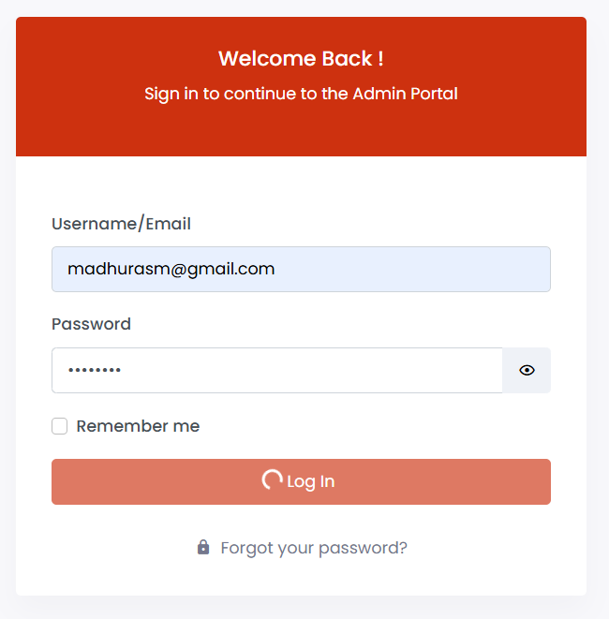

Row No.: 19

|  |  |  |  |  |
| --- | --- | --- | --- | --- |
| **Description** | **Test Steps** | **Expected Output** | **Status** | **Comments** |
| Verify form validation for email format. | 1. Navigate to the receptionist login page 2. Enter an invalid email format (e.g., 'user@' or 'user.com') 3. Enter a valid password 4. Submit the form | 1. Form should validate email format 2. An appropriate error message should be displayed 3. Form should not be submitted until corrected | **Pass** | Gives an error message when invalid email format like (user@) is entered. |

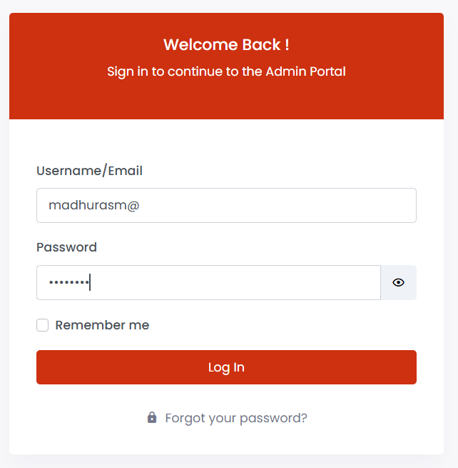

When invalid email like (user@) is entered along with a valid password, the following error message is displayed.

